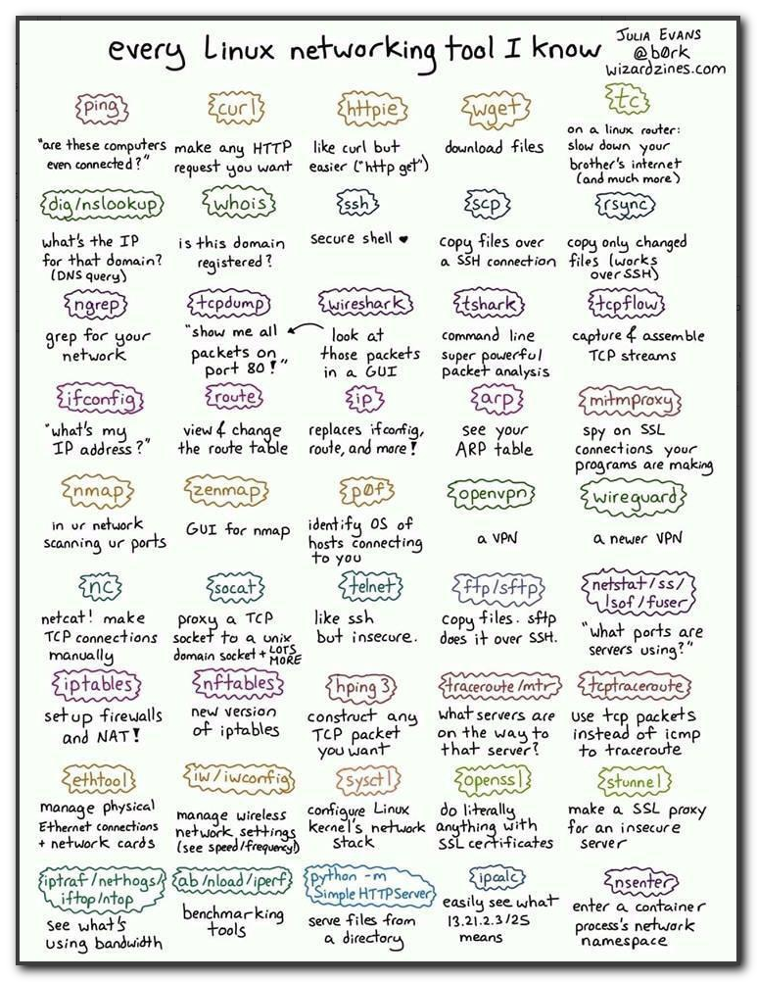

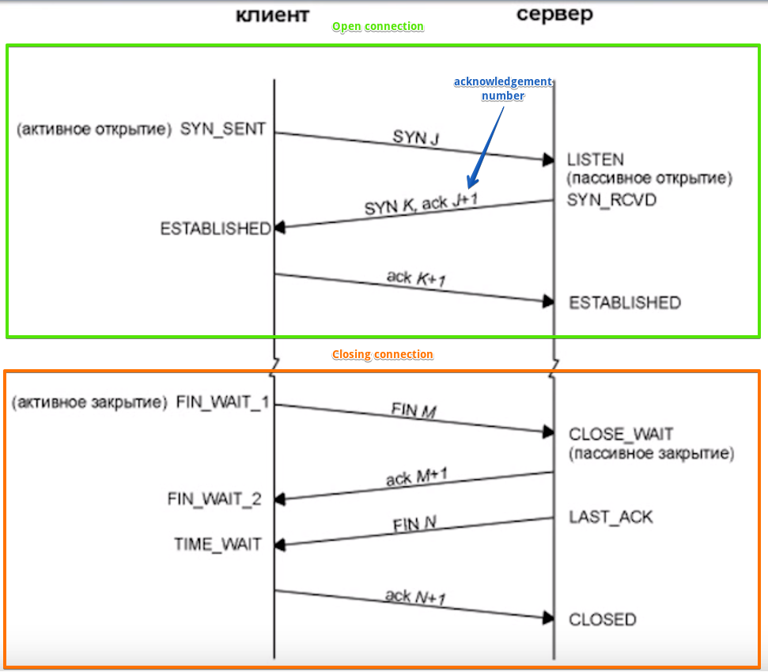

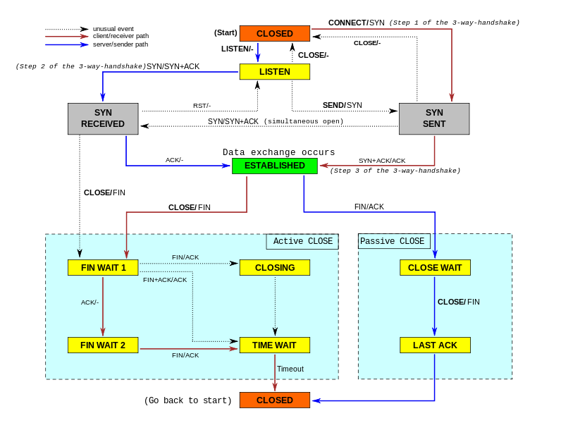

#
# 20190319
# Some examples of successful usage tcpdump, ngrep, tshark

# Test connection to port 80
root@TCS4357:~/work/20190222-1747# telnet dmp-devel.datamind.ru 80
Trying 5.9.28.136...
Connected to dmp-devel.datamind.ru.
Escape character is '^]'.
test
<!DOCTYPE HTML PUBLIC "-//W3C//DTD HTML 4.01//EN"
"http://www.w3.org/TR/html4/strict.dtd">
<html>
<head>
<meta http-equiv="Content-Type" content="text/html;charset=utf-8">
<title>Error response</title>
</head>
<body>
<h1>Error response</h1>
<p>Error code: 400</p>
<p>Message: Bad request syntax ('test').</p>
<p>Error code explanation: 400 - Bad request syntax or unsupported method.</p>
</body>
</html>
Connection closed by foreign host.
root@TCS4357:~/work/20190222-1747#

# Here we can see both type of direction packets: from client to server and answers from server to client. In all connections must present port 80.
root@dmp-devel ~ # tcpdump -v -i any host 91.194.227.252 and host 5.9.28.136 and port 80
tcpdump: listening on any, link-type LINUX_SLL (Linux cooked), capture size 262144 bytes
16:16:14.349278 IP (tos 0x0, ttl 118, id 11333, offset 0, flags [DF], proto TCP (6), length 52)
91.194.227.252.4839 > dmp-devel.datamind.ru.http: Flags [S], cksum 0x2a3a (correct), seq 3451520932, win 64240, options [mss 1460,nop,wscale 8,nop,nop,sackOK], length 0
16:16:14.349291 IP (tos 0x0, ttl 64, id 0, offset 0, flags [DF], proto TCP (6), length 52)
dmp-devel.datamind.ru.http > 91.194.227.252.4839: Flags [S.], cksum 0x4474 (correct), seq 3065952213, ack 3451520933, win 29200, options [mss 1460,nop,nop,sackOK,nop,wscale 9], length 0
16:16:14.390894 IP (tos 0x0, ttl 118, id 11334, offset 0, flags [DF], proto TCP (6), length 40)
91.194.227.252.4839 > dmp-devel.datamind.ru.http: Flags [.], cksum 0xf658 (correct), ack 1, win 256, length 0
16:16:25.873616 IP (tos 0x0, ttl 118, id 11335, offset 0, flags [DF], proto TCP (6), length 46)
91.194.227.252.4839 > dmp-devel.datamind.ru.http: Flags [P.], cksum 0x0167 (correct), seq 1:7, ack 1, win 256, length 6: HTTP
16:16:25.873650 IP (tos 0x0, ttl 64, id 24092, offset 0, flags [DF], proto TCP (6), length 40)
dmp-devel.datamind.ru.http > 91.194.227.252.4839: Flags [.], cksum 0xf718 (correct), ack 7, win 58, length 0
16:16:25.874090 IP (tos 0x0, ttl 64, id 24093, offset 0, flags [DF], proto TCP (6), length 516)
dmp-devel.datamind.ru.http > 91.194.227.252.4839: Flags [P.], cksum 0x85e6 (correct), seq 1:477, ack 7, win 58, length 476: HTTP
16:16:25.874212 IP (tos 0x0, ttl 64, id 24094, offset 0, flags [DF], proto TCP (6), length 40)
dmp-devel.datamind.ru.http > 91.194.227.252.4839: Flags [F.], cksum 0xf53b (correct), seq 477, ack 7, win 58, length 0
16:16:25.916389 IP (tos 0x0, ttl 118, id 11336, offset 0, flags [DF], proto TCP (6), length 40)
91.194.227.252.4839 > dmp-devel.datamind.ru.http: Flags [.], cksum 0xf477 (correct), ack 478, win 254, length 0
16:16:25.923722 IP (tos 0x0, ttl 118, id 11337, offset 0, flags [DF], proto TCP (6), length 40)
91.194.227.252.4839 > dmp-devel.datamind.ru.http: Flags [F.], cksum 0xf476 (correct), seq 7, ack 478, win 254, length 0
16:16:25.923733 IP (tos 0x0, ttl 64, id 42350, offset 0, flags [DF], proto TCP (6), length 40)
dmp-devel.datamind.ru.http > 91.194.227.252.4839: Flags [.], cksum 0xf53a (correct), ack 8, win 58, length 0
^C
10 packets captured
10 packets received by filter
0 packets dropped by kernel
root@dmp-devel ~ #

# Collect tcpdump into a file.
root@dmp-devel ~ # tcpdump -n -v -i any host 87.251.184.146 and host 5.9.28.136 and port 80 -w /var/tmp/20190314-1620.tcpdump.between.87.251.184.146.and.5.9.28.136.dat
tcpdump: listening on any, link-type LINUX_SLL (Linux cooked), capture size 262144 bytes
^C18 packets captured
18 packets received by filter
0 packets dropped by kernel
root@dmp-devel ~ #

# Look inside collected tcpdump file.
root@dmp-devel ~ # tshark -r /var/tmp/20190314-1620.tcpdump.between.87.251.184.146.and.5.9.28.136.dat -V | less
Frame 1: 68 bytes on wire (544 bits), 68 bytes captured (544 bits)
Encapsulation type: Linux cooked-mode capture (25)
Arrival Time: Mar 14, 2019 16:21:42.801686000 MSK
[Time shift for this packet: 0.000000000 seconds]
Epoch Time: 1552569702.801686000 seconds
[Time delta from previous captured frame: 0.000000000 seconds]
[Time delta from previous displayed frame: 0.000000000 seconds]
[Time since reference or first frame: 0.000000000 seconds]
Frame Number: 1
Frame Length: 68 bytes (544 bits)
Capture Length: 68 bytes (544 bits)
[Frame is marked: False]
[Frame is ignored: False]
[Protocols in frame: sll:ethertype:ip:tcp]
Linux cooked capture
Packet type: Unicast to us (0)
Link-layer address type: 1
Link-layer address length: 6
Source: JuniperN_76:ae:22 (84:c1:c1:76:ae:22)
Unused: 0000
Protocol: IPv4 (0x0800)
Internet Protocol Version 4, Src: 87.251.184.146, Dst: 5.9.28.136
0100 .... = Version: 4
.... 0101 = Header Length: 20 bytes (5)
Differentiated Services Field: 0x00 (DSCP: CS0, ECN: Not-ECT)
0000 00.. = Differentiated Services Codepoint: Default (0)
.... ..00 = Explicit Congestion Notification: Not ECN-Capable Transport (0)
Total Length: 52
Identification: 0x6c48 (27720)
Flags: 0x4000, Don't fragment
0... .... .... .... = Reserved bit: Not set
.1.. .... .... .... = Don't fragment: Set
..0. .... .... .... = More fragments: Not set
...0 0000 0000 0000 = Fragment offset: 0
Time to live: 115
Protocol: TCP (6)
Header checksum: 0x695d [validation disabled]
[Header checksum status: Unverified]
Source: 87.251.184.146
Destination: 5.9.28.136
Transmission Control Protocol, Src Port: 17264, Dst Port: 80, Seq: 0, Len: 0
Source Port: 17264
Destination Port: 80
[Stream index: 0]
[TCP Segment Len: 0]
Sequence number: 0 (relative sequence number)
[Next sequence number: 0 (relative sequence number)]
Acknowledgment number: 0
1000 .... = Header Length: 32 bytes (8)
Flags: 0x002 (SYN)
000. .... .... = Reserved: Not set
...0 .... .... = Nonce: Not set
.... 0... .... = Congestion Window Reduced (CWR): Not set
.... .0.. .... = ECN-Echo: Not set
.... ..0. .... = Urgent: Not set
.... ...0 .... = Acknowledgment: Not set
.... .... 0... = Push: Not set
.... .... .0.. = Reset: Not set
.... .... ..1. = Syn: Set
[Expert Info (Chat/Sequence): Connection establish request (SYN): server port 80]
[Connection establish request (SYN): server port 80]
[Severity level: Chat]
[Group: Sequence]
.... .... ...0 = Fin: Not set
[TCP Flags: ··········S·]
Window size value: 64240
[Calculated window size: 64240]
Checksum: 0x2c3a [unverified]
[Checksum Status: Unverified]
Urgent pointer: 0
Options: (12 bytes), Maximum segment size, No-Operation (NOP), Window scale, No-Operation (NOP), No-Operation (NOP), SACK permitted
TCP Option - Maximum segment size: 1460 bytes
Kind: Maximum Segment Size (2)
Length: 4
MSS Value: 1460
TCP Option - No-Operation (NOP)
Kind: No-Operation (1)
TCP Option - Window scale: 8 (multiply by 256)
Kind: Window Scale (3)
Length: 3
Shift count: 8
[Multiplier: 256]
TCP Option - No-Operation (NOP)
Kind: No-Operation (1)
TCP Option - No-Operation (NOP)
Kind: No-Operation (1)
TCP Option - SACK permitted
Kind: SACK Permitted (4)
Length: 2
[Timestamps]
[Time since first frame in this TCP stream: 0.000000000 seconds]
[Time since previous frame in this TCP stream: 0.000000000 seconds]
...

# Test connection to port 80 with ngrep.
root@TCS4357:~/work/20190222-1747# telnet dmp-devel.datamind.ru 80
Trying 5.9.28.136...
Connected to dmp-devel.datamind.ru.
Escape character is '^]'.
test
<!DOCTYPE HTML PUBLIC "-//W3C//DTD HTML 4.01//EN"
"http://www.w3.org/TR/html4/strict.dtd">
<html>
<head>
<meta http-equiv="Content-Type" content="text/html;charset=utf-8">
<title>Error response</title>
</head>
<body>
<h1>Error response</h1>
<p>Error code: 400</p>
<p>Message: Bad request syntax ('test').</p>
<p>Error code explanation: 400 - Bad request syntax or unsupported method.</p>
</body>
</html>
Connection closed by foreign host.
root@TCS4357:~/work/20190222-1747#

# How looks connection to port 80 in ngrep utility.
root@dmp-devel ~ # ngrep -W byline '' host 91.194.227.252 and port 80
interface: eth0 (5.9.28.128/255.255.255.224)
filter: (ip or ip6) and ( host 91.194.227.252 and port 80 )
###
T 91.194.227.252:6213 -> 5.9.28.136:80 [A]
..C..S
#
T 91.194.227.252:6213 -> 5.9.28.136:80 [AP]
test.

##
T 5.9.28.136:80 -> 91.194.227.252:6213 [AP]
<!DOCTYPE HTML PUBLIC "-//W3C//DTD HTML 4.01//EN"
"http://www.w3.org/TR/html4/strict.dtd">
<html>
<head>
<meta http-equiv="Content-Type" content="text/html;charset=utf-8">
<title>Error response</title>
</head>
<body>
<h1>Error response</h1>
<p>Error code: 400</p>
<p>Message: Bad request syntax ('test').</p>
<p>Error code explanation: 400 - Bad request syntax or unsupported method.</p>
</body>
</html>

##
T 91.194.227.252:6213 -> 5.9.28.136:80 [A]
...A4f
#
T 91.194.227.252:6213 -> 5.9.28.136:80 [AF]
...R..
#^Cexit
11 received, 0 dropped
root@dmp-devel ~ #

#
# 20190415
# Tcpdump udp packets. This example is for openvpn connection - it work via udp and use port 1194.
#
root@ds-advert-prod-vault-1:~# tcpdump -n -v -i any udp port 1194
tcpdump: listening on any, link-type LINUX_SLL (Linux cooked), capture size 262144 bytes
20:53:05.682922 IP (tos 0x0, ttl 55, id 60466, offset 0, flags [DF], proto UDP (17), length 82)
148.251.6.45.49647 > 10.218.9.86.1194: UDP, length 54
...
20:54:06.528219 IP (tos 0x0, ttl 55, id 2847, offset 0, flags [DF], proto UDP (17), length 109)
148.251.6.45.49647 > 10.218.9.86.1194: UDP, length 81

36 packets captured
36 packets received by filter
0 packets dropped by kernel
root@ds-advert-prod-vault-1:~#

https://markhneedham.com/blog/2012/07/15/tcpdump-learning-how-to-read-udp-packets/
tcpdump: Learning how to read UDP packets

tcpdump: Learning how to read UDP packets
Phil and I spent some of Friday afternoon configuring statsd:
A network daemon that runs on the Node.js platform and listens for statistics, like counters and timers, sent over UDP and sends aggregates to one or more pluggable backend services
We configured it to listen on its default port 8125 and then used netcat to send UDP packets to see if it was working like so:

echo -n "blah:36|c" | nc -w 1 -u -4 localhost 8125

We used tcpdump to capture any UDP packets on port 8125 like so:

tcpdump -i lo udp port 8125 -vv -X

To briefly explain the options we passed to it:
- -i lo only captures packets on the local loopback i.e. packets sent to localhost
- udp means that only UDP packets will be captured. Other types of packets we might capture could be tcp or icmp for example.
- -vv just gives us more verbose output
- -X prints out the data in the UDP packets in ASCII as well as hex. If we just wanted the latter we could use the -x option
This is what one of the messages received by tcpdump looks like:

13:16:40.317636 IP (tos 0x0, ttl 64, id 58103, offset 0, flags [DF], proto UDP (17), length 37)
localhost.48358 > localhost.8125: [bad udp cksum 7c8f!] UDP, length 9
0x0000: 4500 0025 e2f7 4000 4011 59ce 7f00 0001 E..%..@.@.Y.....
0x0010: 7f00 0001 bce6 1fbd 0011 fe24 626c 6168 ...........$blah
0x0020: 3a33 367c 63 :36|c

The last three lines of this output detail the IP header, UDP header and the data in the packet. The following diagram is quite useful for understanding what each part of the IP header is defining:
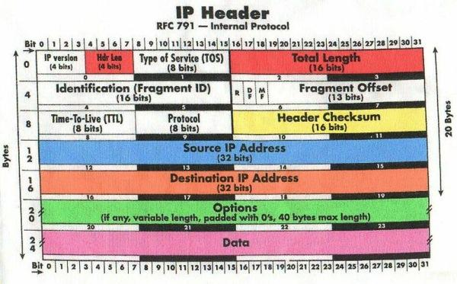
Source: WTCS.org
This diagram defines things in terms of bits whereas the tcpdump output is in hexidecimal. Each block of 4 hexidecimal digits is equivalent to 16 bits.
There are a couple of parts of the IP header that might be interesting to us in this case.
The first 4 bits/1 digit define the IP version which is 4 in this case since we’re using IPv4.
The next 4 bits define the Internet Header length - the number of 32 bit words in the header. In this case the value is 5 so we know the total length of the IP header will be 160 bits (5 * 32 = 160).
The next few bits aren’t that interesting but we can see the source IP address at an offset of 96 bits and covers the next 32 bits:
0x0000: 4500 0025 e2f7 4000 4011 59ce 7f00 0001
We know this is going to represent an IPv4 address so it will be represented as ‘x.x.x.x’ where the maximum value of x is 255.
In this case since we’re just sending packets locally it translates to 127.0.0.1:
- 7f => 127
- 00 => 0
- 00 => 0
- 01 => 1
The next 32 bits are the destination IP address which has now gone onto the next line but is exactly the same:
0x0010: 7f00 0001 bce6 1fbd 0011 fe24 626c 6168
We’ve now covered 160 bits which means that the IP header is complete and we can move onto the IP payload which starts with the UDP header:
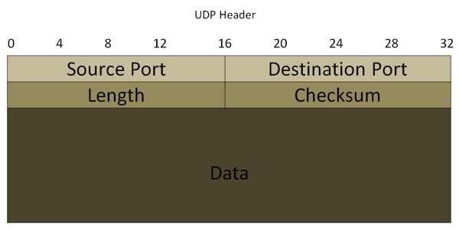
Source: ciscoskills.net
We start with the source port which is ‘bce6’ or 48358 in decimal. We can see that value referenced in the 2nd line of the tcpdump output as well.
The next 16 bits/4 digits are the destination port which is ‘1fbd’ or 8125 in decimal - exactly what we’d expect.
The next 32 bits/2 blocks of 4 digits define the length and checksum but after that we reach the data part of the packet which should contain ‘blah:36|c’.
The word ‘blah’ is defined like so:

626c 6168

00x62 is 98 in decimal and we can use a UTF-8 encoding table to see that 98 maps to the letter ‘b’.
00x6c is 108 or the letter ‘l’, 00x61 is 97 or the letter ‘a’ and 00x68 is 104 or the letter ‘h’
We wrap onto the last line for the rest of the data we wanted to send to statsd:

0x0020: 3a33 367c 63

It follows the same pattern though where 00x3a is 58 or the ‘:’ character and so on.
And now I have a slightly better idea of how to read tcpdump’s output than I did when I started writing this! As usual any tips or hints are welcome.

From: Belogrud Sergey Vladimirovich
Sent: Tuesday, November 10, 2015 9:16 PM
To: Aleksandrov Aleksey Valerievich
Cc: Bukovnya Sergey Nikolaevich
Subject: RE: ACQAPI - ONLINE

В старых серверах старый tcpdump ловит только первые 68 байт пакета!

[root@m1-pr-onl01 ~]# cat /etc/redhat-release
Red Hat Enterprise Linux Server release 5.5 (Tikanga)

[root@vm-pr-onlapp02t ~]# man tcpdump
…
-s Snarf snaplen bytes of data from each packet rather than the default of 68 (with SunOS’s NIT, the minimum is actually 96). 68 bytes is
adequate for IP, ICMP, TCP and UDP but may truncate protocol information from name server and NFS packets (see below). Packets trun-
cated because of a limited snapshot are indicated in the output with ‘‘[|proto]’’, where proto is the name of the protocol level at
which the truncation has occurred. Note that taking larger snapshots both increases the amount of time it takes to process packets and,
effectively, decreases the amount of packet buffering. This may cause packets to be lost. You should limit snaplen to the smallest
number that will capture the protocol information you’re interested in. Setting snaplen to 0 means use the required length to catch
whole packets.
…

[root@vm-pr-onlapp02t ~]# rpm -qi tcpdump
Name : tcpdump Relocations: /usr
Version : 3.9.4 Vendor: Red Hat, Inc.
Release : 15.el5 Build Date: Wed 11 Nov 2009 06:30:39 PM MSK
Install Date: Mon 08 Aug 2011 11:53:51 AM MSK Build Host: ls20-bc2-14.build.redhat.com
Group : Applications/Internet Source RPM: tcpdump-3.9.4-15.el5.src.rpm
Size : 1001294 License: BSD
Signature : DSA/SHA1, Mon 23 Nov 2009 11:56:23 AM MSK, Key ID 5326810137017186
Packager : Red Hat, Inc. <http://bugzilla.redhat.com/bugzilla>
URL : http://www.tcpdump.org
Summary : A network traffic monitoring tool.
Description :
Tcpdump is a command-line tool for monitoring network traffic.
Tcpdump can capture and display the packet headers on a particular
network interface or on all interfaces. Tcpdump can display all of
the packet headers, or just the ones that match particular criteria.

Install tcpdump if you need a program to monitor network traffic.
[root@vm-pr-onlapp02t ~]#

А это современные версии tcpdump.

man tcpdump
…
-s Snarf snaplen bytes of data from each packet rather than the default of 65535 bytes. Packets truncated because of a limited snapshot are indicated in the output with ‘‘[|proto]’’, where proto is the name of the protocol level
at which the truncation has occurred. Note that taking larger snapshots both increases the amount of time it takes to process packets and, effectively, decreases the amount of packet buffering. This may cause packets to be
lost. You should limit snaplen to the smallest number that will capture the protocol information you’re interested in. Setting snaplen to 0 sets it to the default of 65535, for backwards compatibility with recent older ver-
sions of tcpdump.
…

[support@centos00 en]$ rpm -q tcpdump
tcpdump-4.0.0-3.20090921gitdf3cb4.2.el6.x86_64
[support@centos00 en]$ rpm -qi tcpdump
Name : tcpdump Relocations: (not relocatable)
Version : 4.0.0 Vendor: CentOS
Release : 3.20090921gitdf3cb4.2.el6 Build Date: Mon 26 Mar 2012 04:56:48 PM MSK
Install Date: Wed 28 Aug 2013 02:14:35 PM MSK Build Host: c6b6.bsys.dev.centos.org
Group : Applications/Internet Source RPM: tcpdump-4.0.0-3.20090921gitdf3cb4.2.el6.src.rpm
Size : 832443 License: BSD with advertising
Signature : RSA/SHA1, Mon 26 Mar 2012 05:32:34 PM MSK, Key ID 0946fca2c105b9de
Packager : CentOS BuildSystem <http://bugs.centos.org>
URL : http://www.tcpdump.org
Summary : A network traffic monitoring tool
Description :
Tcpdump is a command-line tool for monitoring network traffic.
Tcpdump can capture and display the packet headers on a particular
network interface or on all interfaces. Tcpdump can display all of
the packet headers, or just the ones that match particular criteria.

Install tcpdump if you need a program to monitor network traffic.
[support@centos00 en]$

20151106
# This command work on RedHat 5.5.
[root@vm-pr-onlapp02t ~]# tcpdump -i eth0 host 10.217.13.39 or host 10.217.13.38 -C 1024 -W 5 -w /var/tmp/$(date +%Y%m%d-%H%M).tcpdump.pcap
tcpdump: listening on eth0, link-type EN10MB (Ethernet), capture size 96 bytes
86076 packets captured
86078 packets received by filter
0 packets dropped by kernel
[root@vm-pr-onlapp02t ~]#

# -c count -> count of packets.
# -C file_size -> file size where dump writes.
# -W filecount -> number of files with size “-C file_size” will be created if dump write to file.
# -w file -> file name, where to write dump.

# This command will output amount of captured packets online.
tcpdump -i eth0 host 10.217.50.93 -C 1024 -W 10 -w /var/tmp/$(date +%Y%m%d-%H%M).tcpdump.pcap.

# If we use this command line, we will have nothing into file nohup.ouput.txt... This is no good.
[root@vm-social-master01p tmp]# at 18:52 today <<< 'nohup time -f "Elapsed real time: %E\n" timeout 3m tcpdump -v -i eth0 host 10.217.50.93 -C 1024 -W 10 -z gzip -w /var/tmp/$(date +%Y%m%d-%H%M).tcpdump.pcap. > /var/tmp/$(date +%Y%m%d-%H%M).nohup.output.txt &'

# Same results as I have gotten with "at" command, I have it if I use crontab...
# I still have nothing into file nohup.output.txt...
56 19 16 4 * /bin/bash -c '/usr/bin/nohup /usr/bin/time -f "Elapsed real time: \%E\n" /usr/bin/timeout 3m /usr/sbin/tcpdump -v -i eth0 host 10.217.50.93 -C 1024 -W 10 -z gzip -w /var/tmp/$(date +\%Y\%m\%d-\%H\%M).tcpdump.pcap. > /var/tmp/$(date +\%Y\%m\%d-\%H\%M).nohup.output.txt &'

at 18:00 today <<< 'timeout 63h tcpdump -i bond0:2 host 10.216.98.110 -C 1024 -W 5 -z gzip -w /var/tmp/$(date +%Y%m%d-%H%M).tcpdump.pcap.'

Посмотреть какие пакеты идут с интерфейса eth1 и ip-шника 217...
tcpdump -i eth1 host 217.119.80.119 -n
Посмотреть кратко (-q) кто из сетки 192.168 посылает запросы на порт 3128 интерфейса eth0:0
tcpdump -nn -q -i eth0:0 port 3128 and src net 192.168
Сохранить дамп в файл и потом посмотреть в wireshark
tcpdump -s 1500 -i any host 172.30.0.142 -w ./20141208-1609.tcpdump.test.vpn.workstation.dat
По умолчанию tcpdump сохраняет первые 65535 байт пактета. А здесь зачем-то забираются только первые 1500 байт.
Остановиь процесс нажатием Ctrl+C
If we want to get only headers with minimum data, we should use -s 100 parameter.

Find packets on all interfaces (even lo interface).
tcpdump -nn -q -i any port 161 and src host 172.16.1.11

tcpdump -nn -q -c 50 -i eth6 -i eth7

How to use time and timeout commands.
[root@m1-hadoop-cs01t ~]# time timeout 5s tcpdump -nn -q -c 100 -i any dst host 10.216.40.4 and port 53
tcpdump: verbose output suppressed, use -v or -vv for full protocol decode
listening on any, link-type LINUX_SLL (Linux cooked), capture size 65535 bytes

0 packets captured
0 packets received by filter
0 packets dropped by kernel

real 0m5.016s
user 0m0.003s
sys 0m0.003s
[root@m1-hadoop-cs01t ~]#

Here we find wrong communication tryes. We tell not to show packets that sends to correct servers.
tcpdump -nn -q -c 100 -i any not host 10.216.42.5 and not host 10.216.40.4 and port 53

See connection to the first DNS server or to the second.
[root@smdw_prod ~]# time timeout 60s tcpdump -c 100 -nn -q -i any host 10.216.40.4 or host 10.216.42.5 and port 53

Capture data to file
[root@vm-hadoop01t 20140715-1227]# tcpdump -nn -q -c 50 -i any port 53 -w ./20140715-1255.tcpdump.dat
tcpdump: listening on any, link-type LINUX_SLL (Linux cooked), capture size 65535 bytes
50 packets captured
58 packets received by filter
0 packets dropped by kernel
[root@vm-hadoop01t 20140715-1227]#

See captured data from file.
[root@vm-hadoop01t 20140715-1227]# ngrep -W byline '' -I ./20140715-1255.tcpdump.dat
input: ./20140715-1255.tcpdump.dat
#
U 127.0.0.1:43060 -> 127.0.0.1:53
`............vm-hadoop01t.tcsbank.ru.....
#
…
#
U 10.216.43.111:60806 -> 10.216.40.4:53
.............vm-hadoop01t.tcsbank.ru.....
#
U 10.216.43.111:60806 -> 10.216.40.4:53
.:...........vm-hadoop01t.tcsbank.ru.....
exit
[root@vm-hadoop01t 20140715-1227]#

Если не работает сеть, то для проверки нужно запускать так. Ключ -n чтобы не было лага в 3-5 секунд на попытку разрешить DNS имя
по IP адресу.
tcpdump -n -i eth0
или кратко
tcpdump -n -q -i eth0
или подробнее
tcpdump -n -v -i eth0
Если использовать ключ -e то будут выводится MAC адреса.
Ключ -D покажет доступные для прослушивания интерфейсы.
[root@m1-pr-fg01 ~]# tcpdump -D
1.eth5
2.eth5.1708
3.any (Pseudo-device that captures on all interfaces)
4.lo
[root@m1-pr-fg01 ~]#

=========
Использование ngrep
Here is example of usage of ngrep. If we use it like below, we simulateonesly see incoming requests and write it to file.
ngrep '' -W byline host 172.16.28.74 and port 80 | tee -a 20141208-1447.belogrud.txt
ngrep -W byline '' host 212.49.111.36
ngrep -W byline '' host 89.251.74.254 and port 25
ngrep -W byline '' host 94.230.132.38 and port 110
ngrep -W byline '' -d br0 port 25

===========================================================================

xx. Использование tcpdump
(17:38:12) Соколов Евгений:
------------------------------------------------------------
https://admin.netangels.ru/adminpanel/helpdesk/460182/
Человек не может отправить почту через свой сервер (VDS).
Говорит, что это получсается только при соединении через 3G модем (Мегафон). Через другого прова все работает.
------------------------------------------------------------
Вот что видим в логе при попытке подключения:
u4991:/var/log# grep '83.149.32.212' mail.log
Mar 15 16:32:22 u4991 postfix/smtpd[32552]: connect from unknown[83.149.32.212]
Mar 15 16:32:23 u4991 postfix/smtpd[32552]: lost connection after EHLO from unknown[83.149.32.212]
Mar 15 16:32:23 u4991 postfix/smtpd[32552]: disconnect from unknown[83.149.32.212]

ngrep Также показывает разрыв соединения после нашего ответа на EHLO.
u4991:~# ngrep '' -W byline host 83.149.36.53 and port 25
interface: eth0 (91.201.53.0/255.255.255.0)
filter: (ip or ip6) and ( host 83.149.36.53 and port 25 )
####
T 91.201.53.42:25 -> 83.149.36.53:61123 [AP]
220 u4991.netangels.ru ESMTP Postfix (Debian/GNU).

#
T 83.149.36.53:61123 -> 91.201.53.42:25 [AP]
EHLO c2b2447fe09ede.

##
T 91.201.53.42:25 -> 83.149.36.53:61123 [AP]
250-u4991.netangels.ru.
250-PIPELINING.
250-SIZE 10485760.
250-ETRN.
250-STARTTLS.
250-AUTH PLAIN LOGIN.
250-AUTH=PLAIN LOGIN.
250-ENHANCEDSTATUSCODES.
250-8BITMIME.
250 DSN.

###exit

Запускаем TCPDUMP и просим клиента повторить попытку
u4991:~# tcpdump host 83.149.36.53 -s0 -wfile.pcap
(результат записывается в файл file.pcap)

Для просмотра дампа можно использовать команду
u4991:~# tcpdump -r file.pcap -n
reading from file file.pcap, link-type EN10MB (Ethernet)
16:48:54.015481 IP 83.149.36.53.37114 > 91.201.53.42.25: S 101366936:101366936(0) win 64380 <mss 1380,nop,nop,nop,nop>
16:48:54.015496 IP 91.201.53.42.25 > 83.149.36.53.37114: S 770424672:770424672(0) ack 101366937 win 5840 <mss 1460>
16:48:54.234988 IP 83.149.36.53.37114 > 91.201.53.42.25: . ack 1 win 64380
16:48:54.430029 IP 91.201.53.42.25 > 83.149.36.53.37114: P 1:52(51) ack 1 win 5840
16:48:54.731170 IP 83.149.36.53.37114 > 91.201.53.42.25: P 1:22(21) ack 52 win 64329
16:48:54.731213 IP 91.201.53.42.25 > 83.149.36.53.37114: . ack 22 win 5840
16:48:54.731404 IP 91.201.53.42.25 > 83.149.36.53.37114: P 52:227(175) ack 22 win 5840
16:48:54.931070 IP 83.149.36.53.37114 > 91.201.53.42.25: F 22:22(0) ack 227 win 64154
16:48:54.931491 IP 91.201.53.42.25 > 83.149.36.53.37114: F 227:227(0) ack 23 win 5840
16:48:55.111502 IP 83.149.36.53.37114 > 91.201.53.42.25: . ack 228 win 64154
Видим, что от чела приходит Fin после нашего ответа на его EHLO. Что и является причиной начала конца.

Более подробно можно просмотреть содержимое файла дампа через GUI wireshark.
скачиваем дамп на свой комп, Ставим wireshark. Смотрим:
wireshark file.pcap
То есть клиент сам разрывает соединение. Либо его комп, либо это происходит на оборудовании провайдера. Есть подозрения на второе.

20140422
Another one session that closing on server side.
I have used both of these commands on the same host - my virtualbox host. Into one bash terminal window I run tcpdump and in another one bash terminal window I ran telnet command. It was easy splitted via screen package - wherefore I have seen both session in same time.
[support@centos00 20140416-1558]$ telnet m1-mail55 25
Trying 10.216.8.11...
Connected to m1-mail55.
Escape character is '^]'.
475 access from your network is restricted, try later
Connection closed by foreign host.
[support@centos00 20140416-1558]$

[root@centos00 ~]# tcpdump -i any host 10.0.2.4 and host 10.216.8.11
tcpdump: verbose output suppressed, use -v or -vv for full protocol decode
listening on any, link-type LINUX_SLL (Linux cooked), capture size 65535 bytes
16:39:59.768620 IP 10.0.2.4.47931 > m1-mail55.tcsbank.ru.smtp: Flags [S], seq 1215931655, win 14600, options [mss 1460,sackOK,TS val 2867136002 ecr 0,nop,wscale 7], length 0
16:39:59.771589 IP m1-mail55.tcsbank.ru.smtp > 10.0.2.4.47931: Flags [S.], seq 1464262769, ack 1215931656, win 32768, options [mss 1460], length 0
16:39:59.771628 IP 10.0.2.4.47931 > m1-mail55.tcsbank.ru.smtp: Flags [.], ack 1, win 14600, length 0
16:39:59.773090 IP m1-mail55.tcsbank.ru.smtp > 10.0.2.4.47931: Flags [P.], seq 1:56, ack 1, win 32768, length 55
16:39:59.773112 IP 10.0.2.4.47931 > m1-mail55.tcsbank.ru.smtp: Flags [.], ack 56, win 14600, length 0
16:39:59.773138 IP m1-mail55.tcsbank.ru.smtp > 10.0.2.4.47931: Flags [F.], seq 56, ack 1, win 32768, length 0
16:39:59.773622 IP 10.0.2.4.47931 > m1-mail55.tcsbank.ru.smtp: Flags [F.], seq 1, ack 57, win 14600, length 0
16:39:59.773891 IP m1-mail55.tcsbank.ru.smtp > 10.0.2.4.47931: Flags [.], ack 2, win 32767, length 0
^C
8 packets captured
8 packets received by filter
0 packets dropped by kernel
[root@centos00 ~]#

#
# 20190307
# To use tshark we need to install wireshark first.
[root@m1-gp-prod-mdw 20190604-1250]# yum install wireshark
#
root@m1-mvno-tm-gate01 ~$ cat /etc/redhat-release
CentOS Linux release 7.5.1804 (Core)
root@m1-mvno-tm-gate01 ~$

root@m1-mvno-tm-gate01 ~$ yum install wireshark

root@m1-mvno-tm-gate01 ~$ yum whatprovides *tshark*
...
wireshark-1.10.14-16.el7.x86_64 : Network traffic analyzer
Repo : @base
Matched from:
Filename : /usr/sbin/tshark
Filename : /usr/share/wireshark/tshark.html
Filename : /usr/share/man/man1/tshark.1.gz
...

20151203
# Display time with more human readable format.
[root@m1-kvk-prod-be01 ~]# tshark -t ad -i any -R "ip.addr==10.217.67.8" -n
Running as user "root" and group "root". This could be dangerous.
Capturing on Pseudo-device that captures on all interfaces
2015-12-03 15:03:44.536795980 10.218.2.70 -> 10.217.67.8 NFS 172 V4 Call RENEW CID: 0x80d8
2015-12-03 15:03:44.539787412 10.217.67.8 -> 10.218.2.70 NFS 116 V4 Reply (Call In 3298) RENEW
2015-12-03 15:03:44.539817642 10.218.2.70 -> 10.217.67.8 TCP 68 837 > 2049 [ACK] Seq=105 Ack=49 Win=49130 Len=0 TSval=127647807 TSecr=131603674
66 packets dropped
3 packets captured
[root@m1-kvk-prod-be01 ~]#

Write info about captured packet to output one packet per line. Like the tcpdump.
tshark -i eth0 -R "ip.addr==10.217.50.93" -n

More verbose output.
tshark -i eth0 -R "ip.addr==10.217.50.93" -n -V

See available for capture protocols.
tshark -G protocols

See available to output file format.
tshark -F

To see information from captured file we should use follow command line.
tshark -r /var/tmp/20150415-1157.tcpdump.pcap -V | less

[root@m1-db-dev network-scripts]# whereis tshark
tshark: /usr/sbin/tshark /usr/share/man/man1/tshark.1.gz
[root@m1-db-dev network-scripts]# rpm -qf /usr/sbin/tshark
wireshark-1.2.15-2.el6.x86_64
[root@m1-db-dev network-scripts]#

http://ngrep.sourceforge.net/usage.html

Example: Basic Packet Sniffing
Basic packet sniffing is easy with ngrep. It supports BPF filter logic, which means to say constraining what ngrep sees and displays is as easy as saying something like ``ngrep host foo.bar.com and port 25''. Following are a few examples of common invocations of ngrep to do basic packet sniffing. Please note the usage of ``any'' as the specified ethernet adaptor to attach to; in most recent UNIX libpcap implementations this will instruct ngrep to attach to all interfaces at once, local (lo) and all external interfaces that may be active.

ngrep -d any port 25
Monitor all activity crossing source or destination port 25 (SMTP).
ngrep -d any 'error' port syslog
Monitor any network-based syslog traffic for the occurrence of the word ``error''. ngrep knows how to convert service port names (on UNIX, located in ``/etc/services'') to port numbers.
ngrep -wi -d any 'user|pass' port 21
Monitor any traffic crossing source or destination port 21 (FTP), looking case-insensitively for the words ``user'' or ``pass'', matched as word-expressions (the match term(s) must have non-alphanumeric, delimiting characters surrounding them).

Example: Debugging HTTP interactions
In certain scenarios it is desirous to see how web browsers communicate with web servers, and to inspect the HTTP headers and possibly cookie values that they are exchanging.

In this example, we run an ngrep on a webserver. Since it only has one interface, eth0, we omit specifying the interface manually on the command line and allow ngrep to choose the default interface for us, for convenience.

# ngrep port 80
interface: eth0 (64.90.164.72/255.255.255.252)
filter: ip and ( port 80 )
####
T 67.169.59.38:42167 -> 64.90.164.74:80 [AP]
GET / HTTP/1.1..User-Agent: Mozilla/4.0 (compatible; MSIE 6.0; X11; Linux i
686) Opera 7.21 [en]..Host: www.darkridge.com..Accept: text/html, applicat
ion/xml;q=0.9, application/xhtml+xml;q=0.9, image/png, image/jpeg, image/gi
f, image/x-xbitmap, */*;q=0.1..Accept-Charset: iso-8859-1, utf-8, utf-16, *
;q=0.1..Accept-Encoding: deflate, gzip, x-gzip, identity, *;q=0..Cookie: SQ
MSESSID=5272f9ae21c07eca4dfd75f9a3cda22e..Cookie2: $Version=1..Connection:
Keep-Alive, TE..TE: deflate, gzip, chunked, identity, trailers....
##
T 64.90.164.74:80 -> 67.169.59.38:42167 [AP]
HTTP/1.1 200 OK..Date: Mon, 29 Mar 2004 00:44:40 GMT..Server: Apache/2.0.49
(Unix)..Last-Modified: Tue, 04 Nov 2003 12:09:41 GMT..ETag: "210e23-326-f8
200b40"..Accept-Ranges: bytes..Vary: Accept-Encoding,User-Agent..Content-En
coding: gzip..Content-Length: 476..Keep-Alive: timeout=15, max=100..Connect
ion: Keep-Alive..Content-Type: text/html; charset=ISO-8859-1..Content-Langu
age: en..............}S]..0.|...........H...8........@..\....(.....Dw.%.,..
;.k.....Y>q<........d ...........3.i..kdm.u@d{.Q..\....@..B1.0.2YI^..R.....
....X......X..y...\.....,..(........1...g.......*...j..a.`._@.W....0.....?.
.R.K.j..Y.....>...;kw*U.j.<...\0Tn.l.:......>Fs....'....h.'...u.H4..'.6.vID
I.......N.r.O...}...I.w. ...mX...L.s..{.L.R..-...e....~nu..t.3...H..#..J...
.u.?..]....^..2.....e8v/gP.....].48...qD!..........#y...m}..>/?..#........I
..I..4.P......2:...n8l.......!.Yr&...
##
As you can see, all headers and aspects of the HTTP transmission are exposed in their gory detail. It's a little hard to parse though, so let's see what happens when ``-W byline'' mode is used:

# ngrep -W byline port 80
interface: eth0 (64.90.164.72/255.255.255.252)
filter: ip and ( port 80 )
####
T 67.169.59.38:42177 -> 64.90.164.74:80 [AP]
GET / HTTP/1.1.
User-Agent: Mozilla/4.0 (compatible; MSIE 6.0; X11; Linux i686) Opera ...
Host: www.darkridge.com.
Accept: text/html, application/xml;q=0.9, application/xhtml+xml;q=0.9 ...
Accept-Charset: iso-8859-1, utf-8, utf-16, *;q=0.1.
Accept-Encoding: deflate, gzip, x-gzip, identity, *;q=0.
Cookie: SQMSESSID=5272f9ae21c07eca4dfd75f9a3cda22e.
Cookie2: $Version=1.
Cache-Control: no-cache.
Connection: Keep-Alive, TE.
TE: deflate, gzip, chunked, identity, trailers.
.

##
T 64.90.164.74:80 -> 67.169.59.38:42177 [AP]
HTTP/1.1 200 OK.
Date: Mon, 29 Mar 2004 00:47:25 GMT.
Server: Apache/2.0.49 (Unix).
Last-Modified: Tue, 04 Nov 2003 12:09:41 GMT.
ETag: "210e23-326-f8200b40".
Accept-Ranges: bytes.
Vary: Accept-Encoding,User-Agent.
Content-Encoding: gzip.
Content-Length: 476.
Keep-Alive: timeout=15, max=100.
Connection: Keep-Alive.
Content-Type: text/html; charset=ISO-8859-1.
Content-Language: en.
.
..........}S]..0.|...........H...8........@..\....(.....Dw.%.,..;.k.. ...
.;kw*U.j.<...\0Tn.l.:......>Fs....'....h.'...u.H4..'.6.vIDI.......N.r ...
..H..#..J....u.?..]....^..2.....e8v/gP.....].48...qD!..........#y...m ...
####
(Content visually truncated for display purposes.)

``-W byline'' mode tells ngrep to respect embedded line feeds when they occur. You'll note from the output above that there is still a trailing dot (``.'') on each line, which is the carriage-return portion of the CRLF pair. Using this mode, now the output has become much easier to visually parse.

Example: Processing PCAP dump files, looking for patterns
I had a friend who worked at Network Solutions and among the things he did was analyze huge 500M+ PCAP dump files of DNS traffic, looking for patterns and anomalies. ngrep was an invaluable tool for this purpose; it allowed him to take one instance of a network dump and search it quickly and repeatedly for patterns in the data packets.

To save a PCAP dump file from ngrep is very easy; simply run ngrep as you normally would but add one more command line option: ``-O some.file.dump'' (the name of the file is largely irrelevant). To illustrate another feature of ngrep, we will use the ``-T'' option (print time differential information).

# ngrep -O /tmp/dns.dump -d any -T port domain
interface: any
filter: ip and ( port domain )
output: /tmp/dns.dump
#
U +0.000000 203.115.225.24:53 -> 64.90.164.74:53
.............m.razor2.cloudmark.com.......)........
#
U +0.000281 64.90.164.74:53 -> 203.115.225.24:53
.............m.razor2.cloudmark.com................'.ns1...hostmaster..ws..
..p.... ..:.......)........
#
U +0.078184 195.113.155.7:2949 -> 64.90.164.74:53
.............a.razor2.cloudmark.com.....
#
U +0.000351 64.90.164.74:53 -> 195.113.155.7:2949
.............a.razor2.cloudmark.com..................agony...4..........B..
..............ns1...............ns2...............ns3...X..........@Z.J.j..
........@Z...|..........B..;
^Cexit
6 received, 0 dropped
Note the ``output:'' indicator and timestamp information. Now we have a PCAP dump file, and so let's search it for some patterns:

# ngrep -w 'm' -I /tmp/dns.dump
input: /tmp/dns.dump
match: ((^m\W)|(\Wm$)|(\Wm\W))
#
U 203.115.225.24:53 -> 64.90.164.74:53
.............m.razor2.cloudmark.com.......)........
#
U 64.90.164.74:53 -> 203.115.225.24:53
.............m.razor2.cloudmark.com................'.ns1...hostmaster..ws..
..p.... ..:.......)........
##exit
Above we searched for the letter ``m'', matched as a word (``-w''). This yields two packets.

# ngrep -tD ns3 -I /tmp/dns.dump
input: /tmp/dns.dump
match: ns3
####
U 2004/03/28 20:32:37.088525 64.90.164.74:53 -> 195.113.155.7:2949
.............a.razor2.cloudmark.com..................agony...4..........B..
..............ns1...............ns2...............ns3...X..........@Z.J.j..
........@Z...|..........B..;
exit
Here we've added ``-t'' which means print the absolute timestamp on the packet, and ``-D'' which means replay the packets by the time interval at which they were recorded. The latter is a neat little feature for observing the traffic at the rates/times they originally seen, though in this example it's not terribly effective as there is only one packet being matched.

# ngrep -I /tmp/dns.dump port 80
input: /tmp/dns.dump
filter: ip and ( port 80 )
exit
There's no port 80 traffic in the dump, so of course the BPF filter yields us no results.

Example: Observing binary being transferred across the wire
One interesting feature of ngrep is its ability to take a hexademical (binary) expression and search for that in lieu of a regular expression. ngrep can also display the packets it observes in a hexadecimal format, which is more effective for inspecting binary content patterns.

In this example, we will simply look for a binary pattern in a web stream, but the more obvious usage is to look for a DDoS Zombie's unique binary signature (say, from a command packet), or even a Worm/Virus being transferred across the wire as it propogates itself.

For this test, let's assume we have a GIF on a web server that has the data pattern ``0xc5d5e5f55666768696a6b6c6d6e6'' (hexademical) in it. Once ``-X'' is specified, the expression will be interpreted as a hexademical pattern instead of a regular expression, and the ``0x'' prefix is optional.

To see a packet like this cross the wire:

# ngrep -xX '0xc5d5e5f55666768696a6b6c6d6e6' port 80
interface: eth0 (64.90.164.72/255.255.255.252)
filter: ip and ( port 80 )
match: 0xc5d5e5f55666768696a6b6c6d6e6
###
T 64.90.164.74:80 -> 67.169.59.38:42306 [A]
ff d8 ff e0 00 10 4a 46 49 46 00 01 02 01 00 48 ......JFIF.....H
00 48 00 00 ff ed 13 ba 50 68 6f 74 6f 73 68 6f .H......Photosho
70 20 33 2e 30 00 38 42 49 4d 03 ed 00 00 00 00 p 3.0.8BIM......
00 10 00 48 00 00 00 01 00 01 00 48 00 00 00 01 ...H.......H....
00 01 38 42 49 4d 04 0d 00 00 00 00 00 04 00 00 ..8BIM..........
00 78 38 42 49 4d 03 f3 00 00 00 00 00 08 00 00 .x8BIM..........
00 00 00 00 00 00 38 42 49 4d 04 0a 00 00 00 00 ......8BIM......
00 01 00 00 38 42 49 4d 27 10 00 00 00 00 00 0a ....8BIM'.......
00 01 00 00 00 00 00 00 00 02 38 42 49 4d 03 f5 ..........8BIM..
00 00 00 00 00 48 00 2f 66 66 00 01 00 6c 66 66 .....H./ff...lff
00 06 00 00 00 00 00 01 00 2f 66 66 00 01 00 a1 ........./ff....
99 9a 00 06 00 00 00 00 00 01 00 32 00 00 00 01 ...........2....
00 5a 00 00 00 06 00 00 00 00 00 01 00 35 00 00 .Z...........5..
00 01 00 2d 00 00 00 06 00 00 00 00 00 01 38 42 ...-..........8B
49 4d 03 f8 00 00 00 00 00 70 00 00 ff ff ff ff IM.......p......
ff ff ff ff ff ff ff ff ff ff ff ff ff ff ff ff ................
ff ff 03 e8 00 00 00 00 ff ff ff ff ff ff ff ff ................
ff ff ff ff ff ff ff ff ff ff ff ff ff ff 03 e8 ................
00 00 00 00 ff ff ff ff ff ff ff ff ff ff ff ff ................
ff ff ff ff ff ff ff ff ff ff 03 e8 00 00 00 00 ................
ff ff ff ff ff ff ff ff ff ff ff ff ff ff ff ff ................
ff ff ff ff ff ff 03 e8 00 00 38 42 49 4d 04 08 ..........8BIM..
00 00 00 00 00 10 00 00 00 01 00 00 02 40 00 00 .............@..
02 40 00 00 00 00 38 42 49 4d 04 14 00 00 00 00 .@....8BIM......
00 04 00 00 00 06 38 42 49 4d 04 0c 00 00 00 00 ......8BIM......
12 2a 00 00 00 01 00 00 00 70 00 00 00 57 00 00 .*.......p...W..
01 50 00 00 72 30 00 00 12 0e 00 18 00 01 ff d8 .P..r0..........
ff e0 00 10 4a 46 49 46 00 01 02 01 00 48 00 48 ....JFIF.....H.H
00 00 ff fe 00 26 46 69 6c 65 20 77 72 69 74 74 .....&File writt
65 6e 20 62 79 20 41 64 6f 62 65 20 50 68 6f 74 en by Adobe Phot
6f 73 68 6f 70 a8 20 35 2e 30 ff ee 00 0e 41 64 oshop. 5.0....Ad
6f 62 65 00 64 80 00 00 00 01 ff db 00 84 00 0c obe.d...........
08 08 08 09 08 0c 09 09 0c 11 0b 0a 0b 11 15 0f ................
0c 0c 0f 15 18 13 13 15 13 13 18 11 0c 0c 0c 0c ................
0c 0c 11 0c 0c 0c 0c 0c 0c 0c 0c 0c 0c 0c 0c 0c ................
0c 0c 0c 0c 0c 0c 0c 0c 0c 0c 0c 0c 0c 0c 0c 01 ................
0d 0b 0b 0d 0e 0d 10 0e 0e 10 14 0e 0e 0e 14 14 ................
0e 0e 0e 0e 14 11 0c 0c 0c 0c 0c 11 11 0c 0c 0c ................
0c 0c 0c 11 0c 0c 0c 0c 0c 0c 0c 0c 0c 0c 0c 0c ................
0c 0c 0c 0c 0c 0c 0c 0c 0c 0c 0c 0c 0c 0c 0c 0c ................
ff c0 00 11 08 00 57 00 70 03 01 22 00 02 11 01 ......W.p.."....
03 11 01 ff dd 00 04 00 07 ff c4 01 3f 00 00 01 ............?...
05 01 01 01 01 01 01 00 00 00 00 00 00 00 03 00 ................
01 02 04 05 06 07 08 09 0a 0b 01 00 01 05 01 01 ................
01 01 01 01 00 00 00 00 00 00 00 01 00 02 03 04 ................
05 06 07 08 09 0a 0b 10 00 01 04 01 03 02 04 02 ................
05 07 06 08 05 03 0c 33 01 00 02 11 03 04 21 12 .......3......!.
31 05 41 51 61 13 22 71 81 32 06 14 91 a1 b1 42 1.AQa."q.2.....B
23 24 15 52 c1 62 33 34 72 82 d1 43 07 25 92 53 #$.R.b34r..C.%.S
f0 e1 f1 63 73 35 16 a2 b2 83 26 44 93 54 64 45 ...cs5....&D.TdE
c2 a3 74 36 17 d2 55 e2 65 f2 b3 84 c3 d3 75 e3 ..t6..U.e.....u.
f3 46 27 94 a4 85 b4 95 c4 d4 e4 f4 a5 b5 c5 d5 .F'.............
e5 f5 56 66 76 86 96 a6 b6 c6 d6 e6 f6 37 47 57 ..Vfv........7GW
67 77 87 97 a7 b7 c7 d7 e7 f7 11 00 02 02 01 02 gw..............
04 04 03 04 05 06 07 07 06 05 35 01 00 02 11 03 ..........5.....
21 31 12 04 41 51 61 71 22 13 05 32 81 91 14 a1 !1..AQaq"..2....
b1 42 23 c1 52 d1 f0 33 24 62 e1 72 82 92 43 53 .B#.R..3$b.r..CS
15 63 73 34 f1 25 06 16 a2 b2 83 07 26 35 c2 d2 .cs4.%......&5..
44 93 54 a3 17 64 45 55 36 74 65 e2 f2 b3 84 c3 D.T..dEU6te.....
d3 75 e3 f3 46 94 a4 85 b4 95 c4 d4 e4 f4 a5 b5 .u..F...........
c5 d5 e5 f5 56 66 76 86 96 a6 b6 c6 d6 e6 f6 27 ....Vfv........'
37 47 57 67 77 87 97 a7 b7 c7 ff da 00 0c 03 01 7GWgw...........
00 02 11 03 11 00 3f 00 f2 a5 3a ad 35 ba 40 0e ......?...:.5.@.
04 16 90 78 20 a8 25 07 94 aa d3 19 18 90 41 a2 ...x .%.......A.
13 9a 4b 9b b9 a0 91 c8 3d c8 ef a7 f2 14 46 35 ..K.....=.....F5
af fe 6c 6f f8 73 e3 3b 7e 92 6a ad 2c 30 75 64 ..lo.s.;~.j.,0ud
82 47 fd f9 a7 f3 5c 8a ec d7 b5 e4 d2 4b 79 0d .G....\......Ky.
73 a0 ba 3f f2 49 87 8b 61 4d 88 fd de 40 4a 66 s..?.I..aM...@Jf
51 fd e8 c7 e6 ff 00 03 f4 5a ee 63 d8 76 bd a5 Q........Z.c.v..
a4 76 22 13 29 d9 75 b6 99 b1 ee 7c 71 b8 ca 82 .v".).u....|q...
78 be ad 79 70 f1 1e 1b e1 e9 c5 f3 29 24 92 49 x..yp.......)$.I
0a 49 24 92 52 92 45 c7 c4 bf 25 c5 b4 b7 76 d1 .I$.R.E...%...v.
2e 3c 00 3f 94 ef a2 d5 6f 33 a3 64 e1 63 7a f9 .<.?....o3.d.cz.
0f a9 85 c5 bb 29 f5 18 eb 1c 1c 1d b9 e2 ba 9c .....)..........
ff 00 63 36 fe 7a 69 c9 00 44 4c 87 11 da 3d 57 ..c6.zi..DL...=W
8c 59 0c 4c c4 4f 08 fd 2e 8d 3a da e7 1d 8d 11 .Y.L.O....:.....
22 75 47 ca fb 35 78 d5 d2 c2 1f 7c 87 58 f6 ea "uG..5x....|.X..
06 91 e9 ef fc e4 1b 5f 4c 33 d1 05 a7 68 0f 27 ......._L3...h.'
b9 fc e8 42 4a ac 83 a8 ae 8c 9e e0 84 65 00 23 ...BJ........e.#
23 21 5c 7f 37 0c 7e 6f 47 f5 9f ff d0 f2 ae ca #!\.7.~oG.......
62 36 c1 3a 1f c0 84 cd 69 71 81 c9 47 a6 f6 e3 b6.:....iq..G...
3f 75 41 af 78 e1 ef 12 27 fe 0d bf f9 24 f1 3e ?uA.x...'....$.>
0d 40 e2 24 55 7f 15 f0 80 91 1c 52 e0 85 eb 2a .@.$U......R...*
e2 ff 00 16 3f a4 c2 fc 5c 8a 1a c7 da c2 c6 d9 ....?...\.......
f4 67 c9 05 5f ca ea 37 3c fa 77 1a b2 1b e2 01 .g.._..7<.w.....
81 3d 83 bd 8a 2e a8 67 39 b5 e0 63 90 e6 34 9b .=.....g9..c..4.
00 20 ff 00 68 f1 ec 67 ef a8 63 29 50 e3 00 5f . ..h..g..c)P.._
51 f2 b3 f3 18 79 70 66 70 e5 26 30 e1 a8 65 1f Q....ypfp.&0..e.
ad 9c bf 4e 8e 3e 2c 5f f3 d8 62 f4 dc ac a6 ef ...N.>,_..b.....
a8 02 c0 40 73 8b 86 93 fb df 9c b6 3a 66 36 0d ...@s.......:f6.
6c 73 18 45 b7 6a 2c de ls.E.j,.
#########
Above we specified ``-X'' to tell ngrep to treat the match expression as hexadecimal, and ``-x'' to tell ngrep to print out the patterns it matches in hexadecimal form.

As it turns out, several other packets also matched this pattern, but this should give the prospective user a good idea of how to use hexadecimal patterns and the hex output mode.

http://www.thegeekstuff.com/2009/03/mergecap-and-tshark-merge-packet-dumps-and-analyze-network-traffic/

Mergecap and Tshark: Merge Packet Dumps and Analyze Network Traffic
by RAMESH NATARAJAN on MARCH 23, 2009

Network Switch with Ethernet Cables
Photo courtesy of Michael_P
This article is written by Balakrishnan M

A while back we reviewed 11 examples on how to use editcap utility to capture network dumps. In this article, let us review mergecap utility and tshark commands.

Mergecap is a packet dump combining tool, which will combine multiple dumps into a single dump file. Based on timestamp, the packets are written into the output file in an orderly manner. By default the output file is written in the libpcap format. However using mergecap options, we can generate output in various different format including those that are supported by wireshark tool.

mergecap is available in the wireshark package. Make sure wireshark/ethereal package is installed to use the mergecap.

Combine two dump files into a single output_dump file

Combines input_dump1 and input_dump2 capture files and writes into output_dump file.

# mergecap -v input_dump1 input_dump2 -w output_dump

In this example, input_dump2 contains the packets which are captured after input_dump1. The output_dump will contain intput_dump2 packets in the beginning followed by intput_dump1 packets.

# mergecap input_dump1 input_dump2 -w output_dump -a
Print output dump file to standard output

Combine two network dump files and print the output to the standard output instead of writing to a file.

# mergecap -v input1_dump input2_dump -w -
Print output file in a specific encapsulation format

Use option -T, to get the output file in the desired encapsulation format as shown below.

# mergecap -v -T ether -w merge_cap capture1 capture2 capture3
3. Merge packets of certain length

In this example, the output_dump contains the packets of maximum 100 bytes length.

# mergecap -v -s 100 dump1 dump2 dump3 -w output_dump
Tshark – Packet capture tool

Tshark is a powerful tool to capture network packets, which can be used to analyze the network traffic. It comes with wireshark network analyzer distribution.

Capture network capture continuously

The following example will capture the network packets continuously for 60 seconds. After 60 seconds of capture, it would stop automatically. capture_out contains the packets, which are flown in the network during the last 60 seconds.

# tshark -q -w capture_out -a duration:60

In the following example packets will be printed on the screen and simultaneously it will be written into the output file.

# tshark -S -q -w capture_out -a duration:10
Capture network statistics using tshark

To see how many packets are flowing in the network for a specific interval use the following command.

# tshark -q -w capture_duration1 -a duration:1 -z io,stat,1
Capture network packets for a specific host

Use the following example, to capture the packet flow for a particular host(transmitted and received packets). In this example, we could see that for every second how many packets are flown in the network for the host 192.168.1.185

# tshark -S -q -w capture_duration6 -a duration:6 -z io,stat,1,ip.addr==192.168.1.150
After capturing all the packets for 6 seconds duration, it will print the statistics as like the following,
145 packets dropped
19749 packets captured
IO Statistics
Interval: 1.000 secs
Column #0: ip.addr==192.168.1.185
| Column #0
Time |frames| bytes
000.000-001.000 2733 545242
001.000-002.000 2991 583374
002.000-003.000 3310 650716
003.000-004.000 3236 641896
004.000-005.000 3518 690860
005.000-006.000 3310 654988
006.000-007.000 638 122812
Capture network packets on a specific port

This example captures only the ssh packets.

# tshark -f “tcp port 22” -w capture_out
Capture network packets for specific duration

The following example will capture packets for specific duration (5 seconds), switch over to the next file when capture file size reaches certain size (1000KB).

# tshark -a filesize:1000 -a duration:5 -a files:5 -w ethcap1
Sample output capture filename with size:

ethcap1_00001_20090216174203 - 1000K
ethcap1_00002_20090216174205 - 1000K
ethcap1_00003_20090216174207 - 835K
Other tshark capture commands

Use option -c, to capture the packets upto certain packet count. The following example creates the ethcap1 file only with 10 packets.

# tshark -c 10 -w ethcap1

Use option -r to read network packets from as compressed file.

# tshark -r capture_dump.gz

Use option -r, to displays only specific packet types. The following example creates the file capture_dump only with the rtp packets in the network analyzer.

# tshark -R “rtp” -r capture_dump

Use the filter below to capture the tcp packets which are flowing in the port 1720.

# tshark -f “tcp port 1720”

The following example will capture packets that are coming either to the port 1720 or 1721.

# tshark -f “port 1720 or port 1721” -w capture_dump

By default, tshark will use eth0 device to do the packet capture. You can also specify a specific ethernet adapter using option -i as shown below.

# tshark -i eth1 -w -a duration:10 capture_dump

This article was written by Balakrishnan Mariyappan. He is working in bk Systems (p) Ltd, and interested in contributing to the open source. The Geek Stuff welcomes your tips and guest articles.

20151123

https://tools.ietf.org/html/rfc793

...

[Page 22]

September 1981
Transmission Control Protocol
Functional Specification

+---------+ ---------\ active OPEN
| CLOSED | \ -----------
+---------+<---------\ \ create TCB
| ^ \ \ snd SYN
passive OPEN | | CLOSE \ \
------------ | | ---------- \ \
create TCB | | delete TCB \ \
V | \ \
+---------+ CLOSE | \
| LISTEN | ---------- | |
+---------+ delete TCB | |
rcv SYN | | SEND | |
----------- | | ------- | V
+---------+ snd SYN,ACK / \ snd SYN +---------+
| |<----------------- ------------------>| |
| SYN | rcv SYN | SYN |
| RCVD |<-----------------------------------------------| SENT |
| | snd ACK | |
| |------------------ -------------------| |
+---------+ rcv ACK of SYN \ / rcv SYN,ACK +---------+
| -------------- | | -----------
| x | | snd ACK
| V V
| CLOSE +---------+
| ------- | ESTAB |
| snd FIN +---------+
| CLOSE | | rcv FIN
V ------- | | -------
+---------+ snd FIN / \ snd ACK +---------+
| FIN |<----------------- ------------------>| CLOSE |
| WAIT-1 |------------------ | WAIT |
+---------+ rcv FIN \ +---------+
| rcv ACK of FIN ------- | CLOSE |
| -------------- snd ACK | ------- |
V x V snd FIN V
+---------+ +---------+ +---------+
|FINWAIT-2| | CLOSING | | LAST-ACK|
+---------+ +---------+ +---------+
| rcv ACK of FIN | rcv ACK of FIN |
| rcv FIN -------------- | Timeout=2MSL -------------- |
| ------- x V ------------ x V
\ snd ACK +---------+delete TCB +---------+
------------------------>|TIME WAIT|------------------>| CLOSED |
+---------+ +---------+

TCP Connection State Diagram
Figure 6.

...

20151211

http://xmodulo.com/what-are-popular-packet-sniffers-on-linux.html

What are popular packet sniffers on Linux
Last updated on November 19, 2012 Authored by Dan Nanni 1 Comment
A typical packet sniffer tool captures live packets from networks, decodes them according to protocol specifications, and optionally takes actions according to the parsed packet contents (e.g., in case of security detection systems). Packet sniffing tools are very useful when you diagnose networks or protect against security attacks over networks. The following are several popular open-source packet sniffers available on Linux.
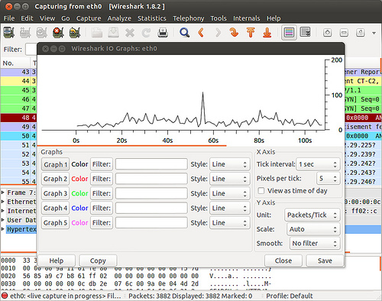
1. tcpdump: The most popular general-purpose packet analyzer. It uses libpcap library to capture packets on OSI layer 2 (e.g., Ethernet, PPP, and SLIP), and above. tcpdump supports regular expressions for advanced packet filtering, and allows one to export and import packet dumps to and from a file.
2. Wireshark: Formerly known as Ethereal, Wireshark is an open-source packet analyzer with graphical front end. Functionality-wise, Wireshark is quite similar to tcpdump, and is available on multiple platforms including Linux, BSD, and Mac OS X, and MS Windows. A CLI client called tshark comes with it.
3. dhcpdump: Snoops on DHCP request/response traffic captured by libpcap library, and displays the DHCP packets in human readable formats. dhcpdump is useful for DHCP debugging and troubleshooting.
4. p0f: A passive OS fingerprinting tool that identifies the operating systems of two end point hosts associated with an existing TCP connection. For accurate fingerprinting, p0f draws from various signatures including TCP/IP headers, TCP three-way handshake dynamics, contents of application-level payloads (e.g., HTTP request/response). Besides OS fingerprinting, p0f also detects the types of HTTP clients, network links (e.g., ethernet, DSL, modem), as well as NAT connection sharing, load-balancing setup, etc.
5. Snort: An open-source intrusion detection and prevention system that relies on real-time network sniffing and analysis. Snort conducts extensive protocol analysis and content matching to detect a variety of network attacks and hostile scans.
6. Kismet: A wireless network detector and intrusion detection system for 802.11 wireless links, supporting 802.11a, 802.11b, 802.11g, and 802.11n. It identifies wireless clients and their network association by passively collecting packets on wireless network card interfaces. Kismet also detects active wireless sniffing programs to alert wireless network attacks.
7. hcidump: A Bluetooth traffic sniffer which captures HCI packets associated with Bluetooth devices, and display Bluetooth related activities in human readable formats.
8. httpry: An open-source HTTP packet sniffing tool which captures live HTTP packets with libpcap library, and displays HTTP requests and responses in a human-readable format. It comes with a collection of parsing Perl scripts for mining various information from its standard output.
9. dsniff: A suite of CLI tools used for network auditing and penetration testing purposes. Supported functionality includes passwords from login sessions (dsniff), sniffing files from NSF traffic (filesnarf), email messages from SMTP/POP traffic (mailsnarf), URLs from web traffic (urlsnarf), etc.
10. ngrep: grep over network packets. Powered with libpcap library, it captures packets whose payload is matched with extended regular expressions or hexadecimal expressions.
11. ntopng: A full-blown web-based real-time network traffic monitoring system which provides flow/protocol/packet-level analysis of local network traffic. Long-term traffic history is archived in the database backend.
12. Wireless IDS: An open source intrusion detection tool for wireless networks. It sniffs communication between wireless devices and access points to detect any potential WEP/WPA/WPS attacking packets, or possible rogue access point.
13. mysql-sniffer: An open source tool which captures live packets sent to a MySQL server, and dumps MySQL queries in a human readable format.
14. bro: A powerful and flexible network monitoring and intrusion detection system. Analyzes live or recorded traffic to trigger events which are then handled by action policies.

#
# 20190816
https://serverfault.com/questions/805006/tcpdump-on-multiple-interfaces

I would capture in 3 terminals or by backgrounding the command with &

The flags -nn turns off dns resolution for speed, -s 0 saves the full packet and -w writes to a file.

tcpdump -i wan0 -nn -s 0 -w wan0.dump
tcpdump -i wan1 -nn -s 0 -w wan1.dump
tcpdump -i lan0 -nn -s 0 -w lan0.dump
I would then merge the files with the mergecap command from wireshark:

mergecap -w merged.dump wan0.dump wan1.dump lan0.dump

